

***INSTITUTE OF INFORMATION TECHNOLOGY***

***JAHANGIRNAGAR UNIVERSITY***

**Number of Assignment :** 01

**Submission Date :** 15/07/2022

**Course Tittle :** Principals of Economics

**Course Code :** ICT - 3109

**Submitted To Submitted By**

Md. Shawkat Ali Md. Shakil Hossain

Professor Roll – 2023

Department of Economics 3nd year 1st Semester

IIT – JU IIT – JU

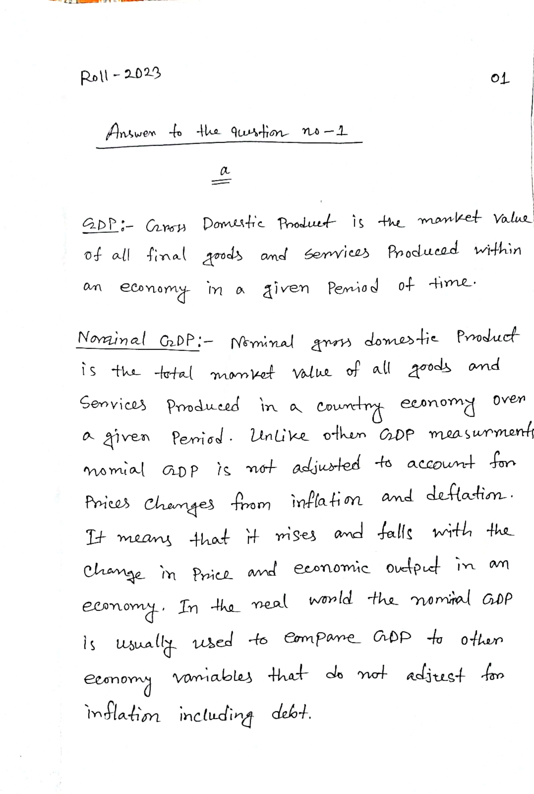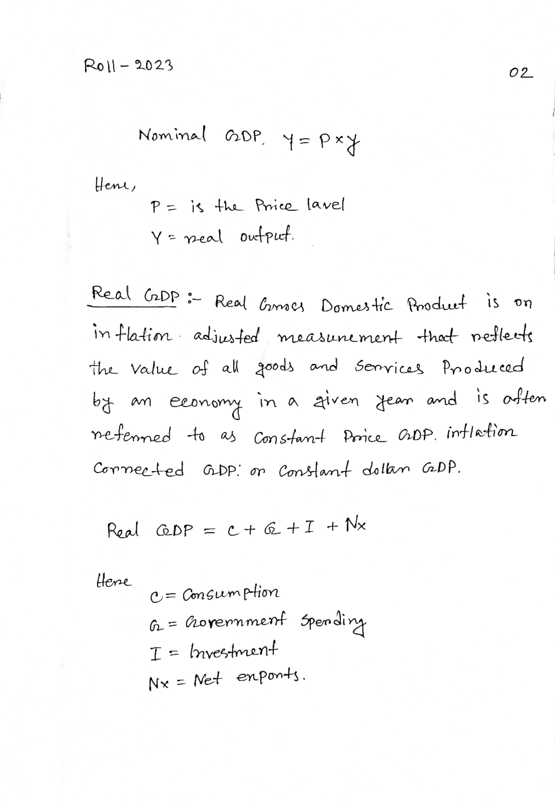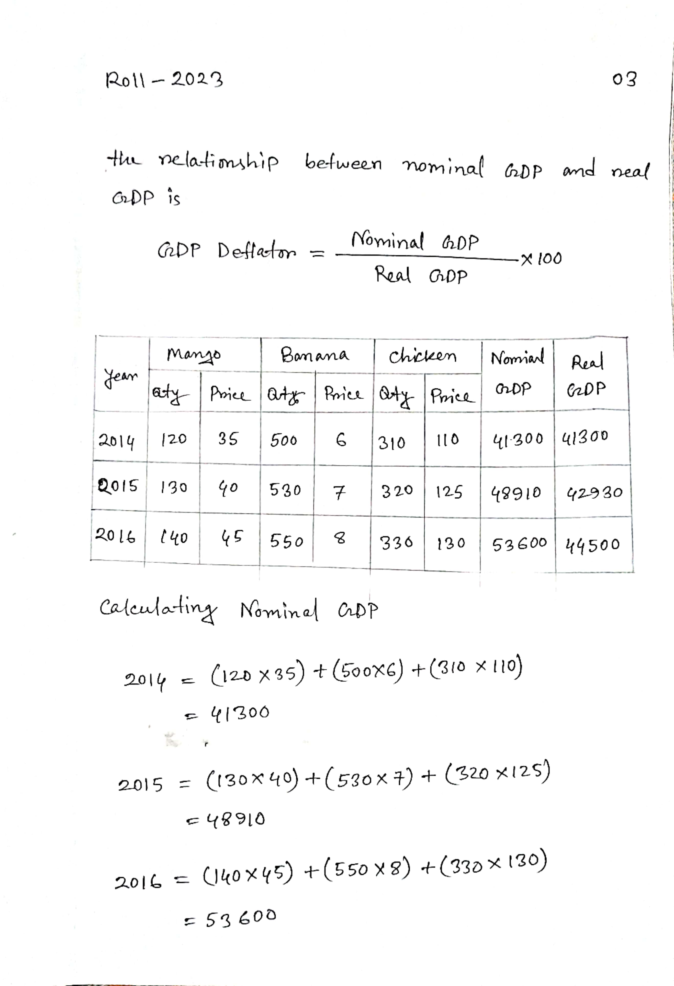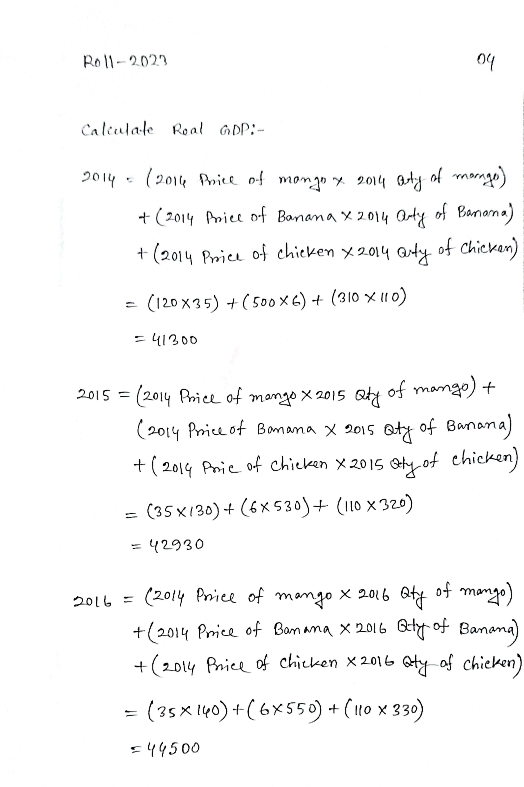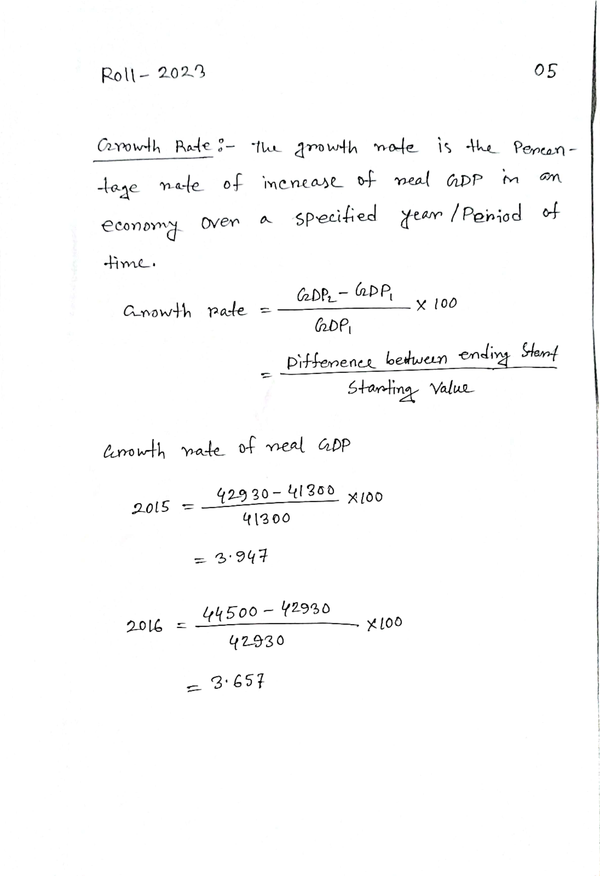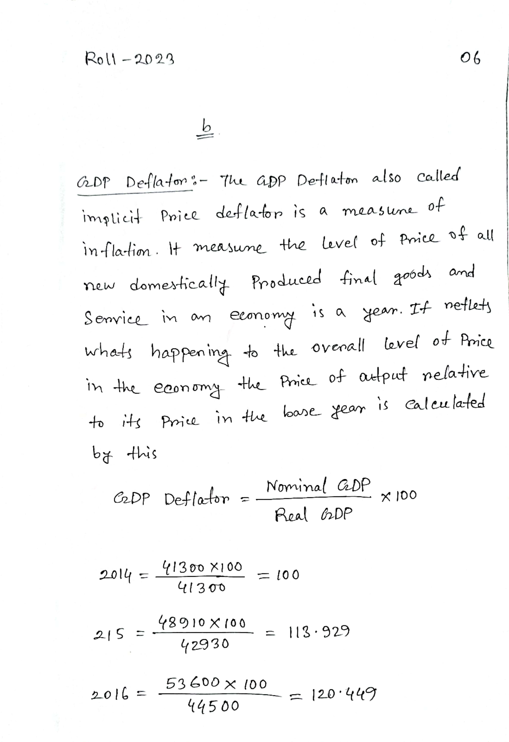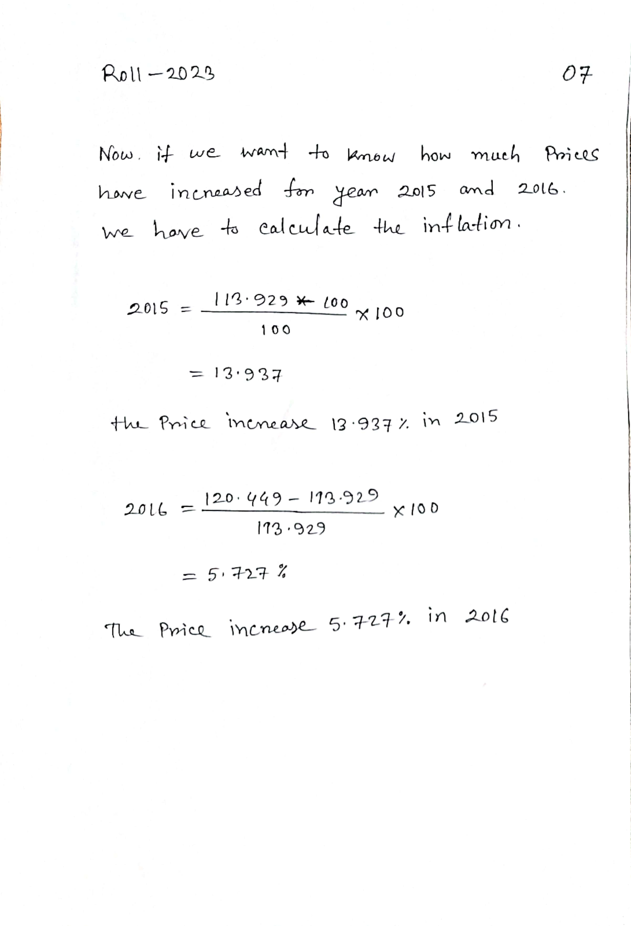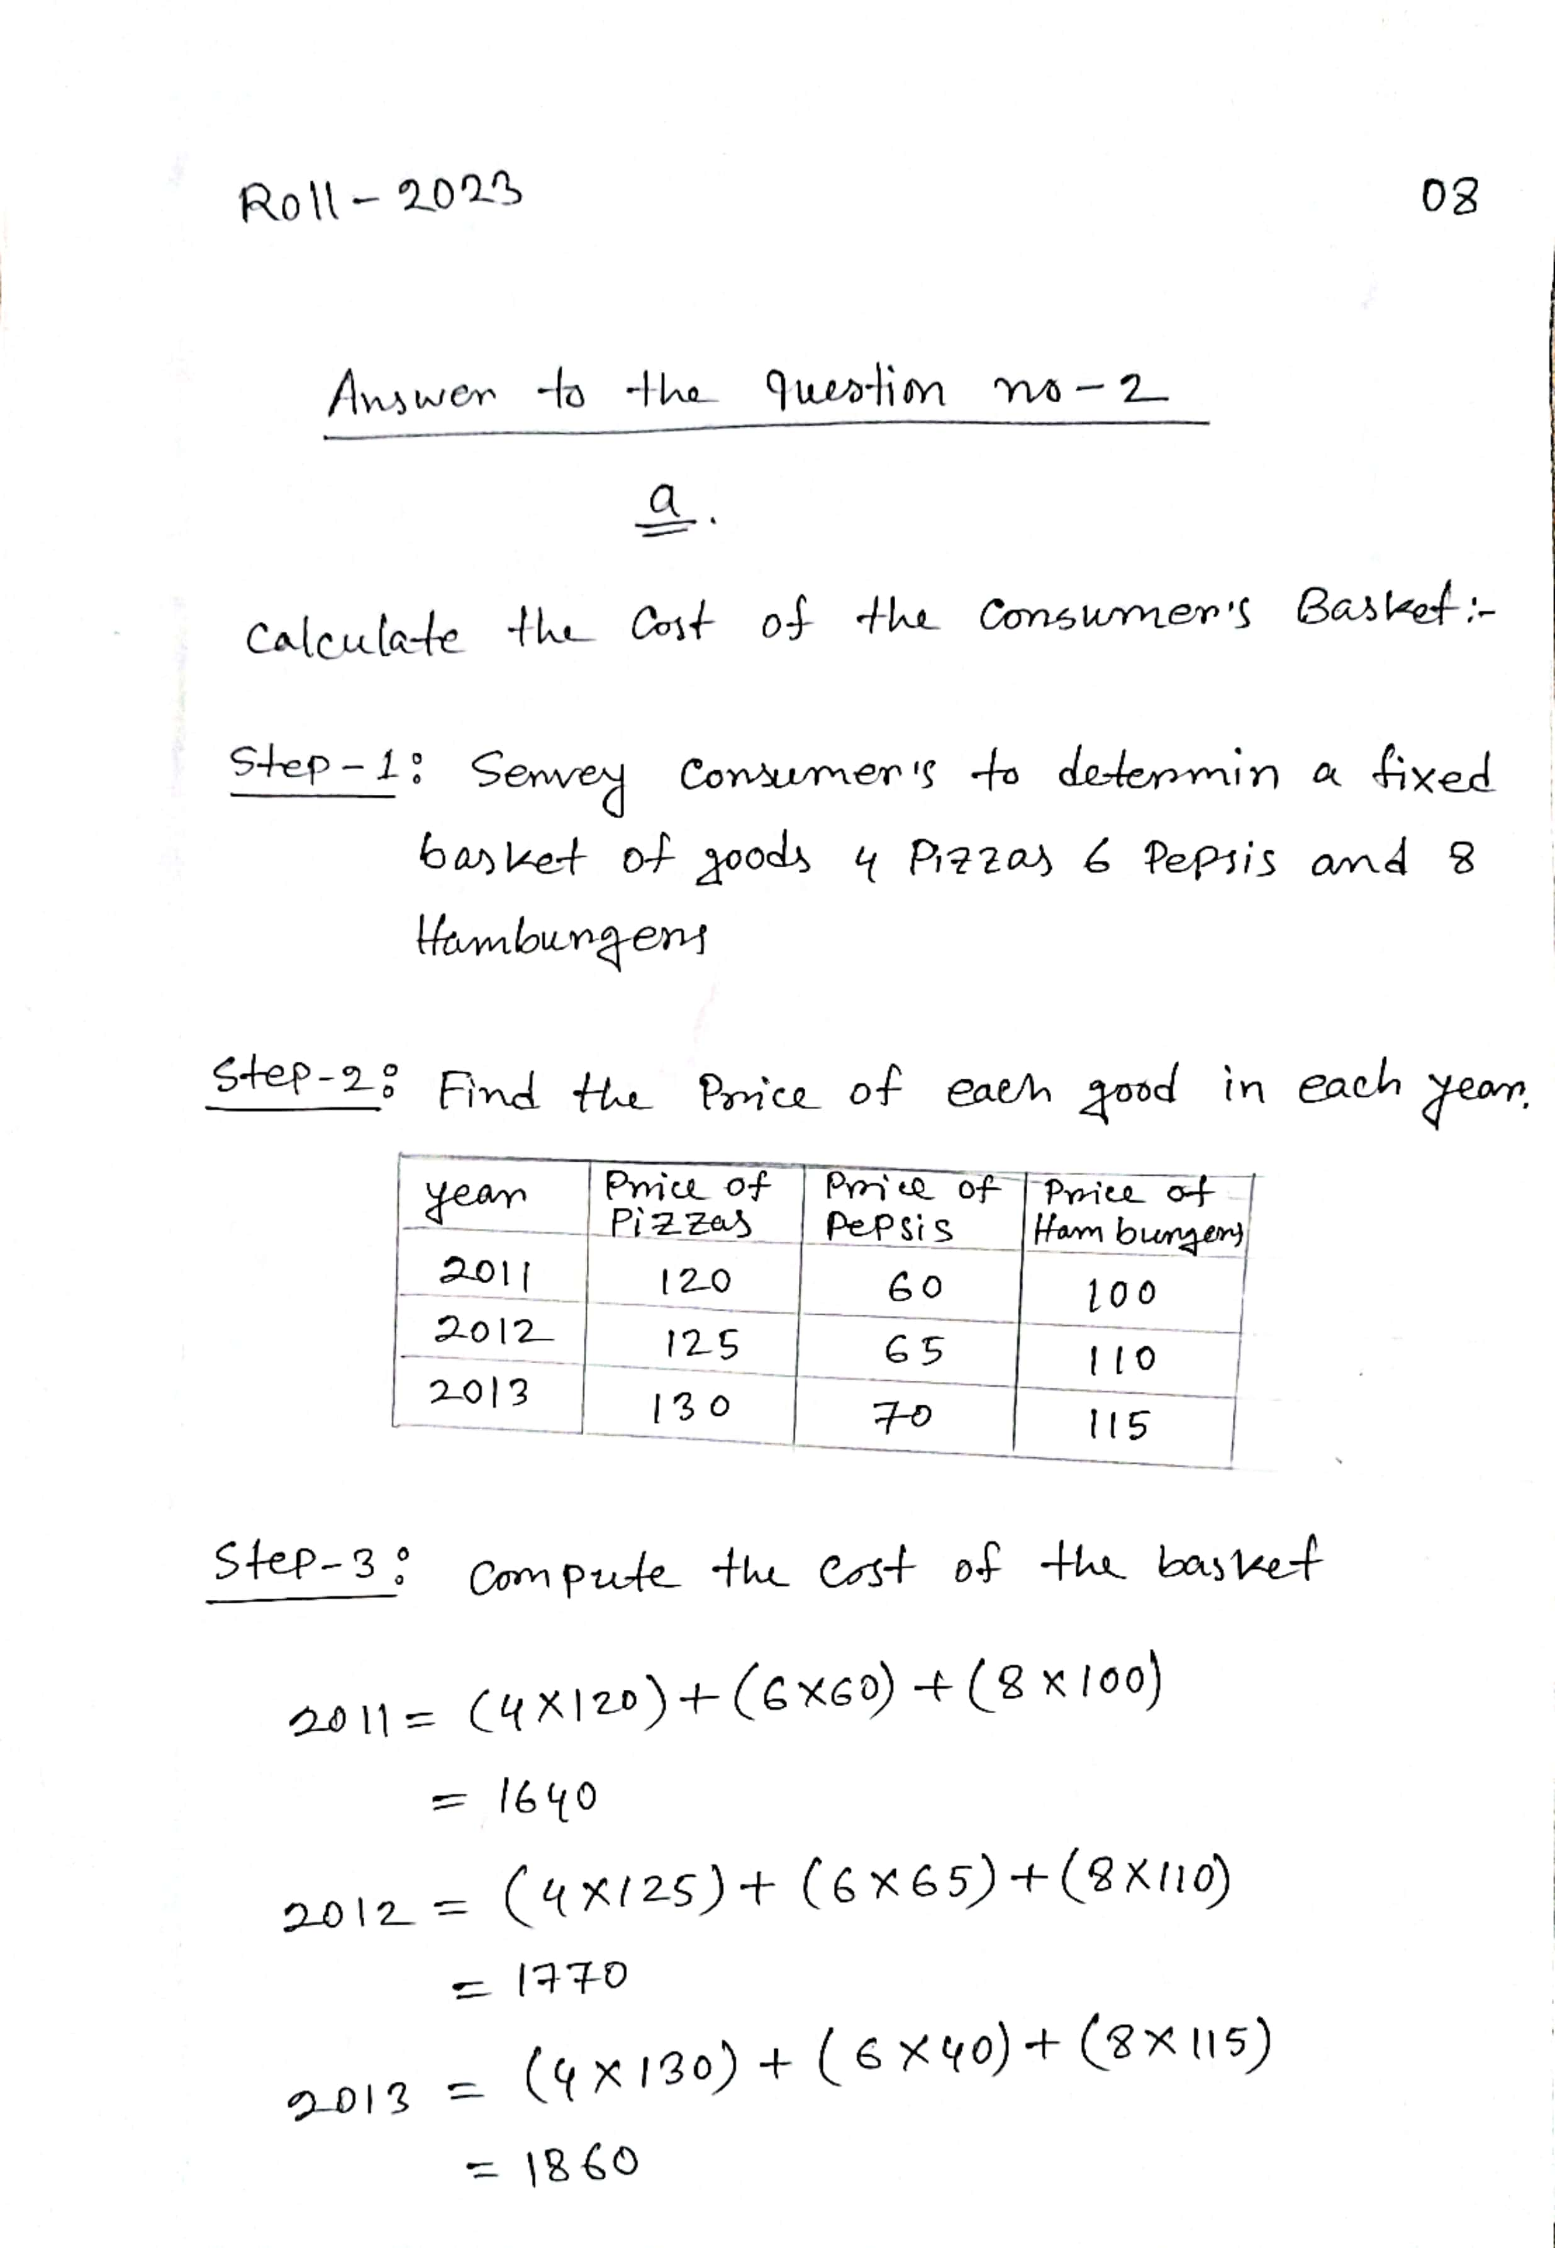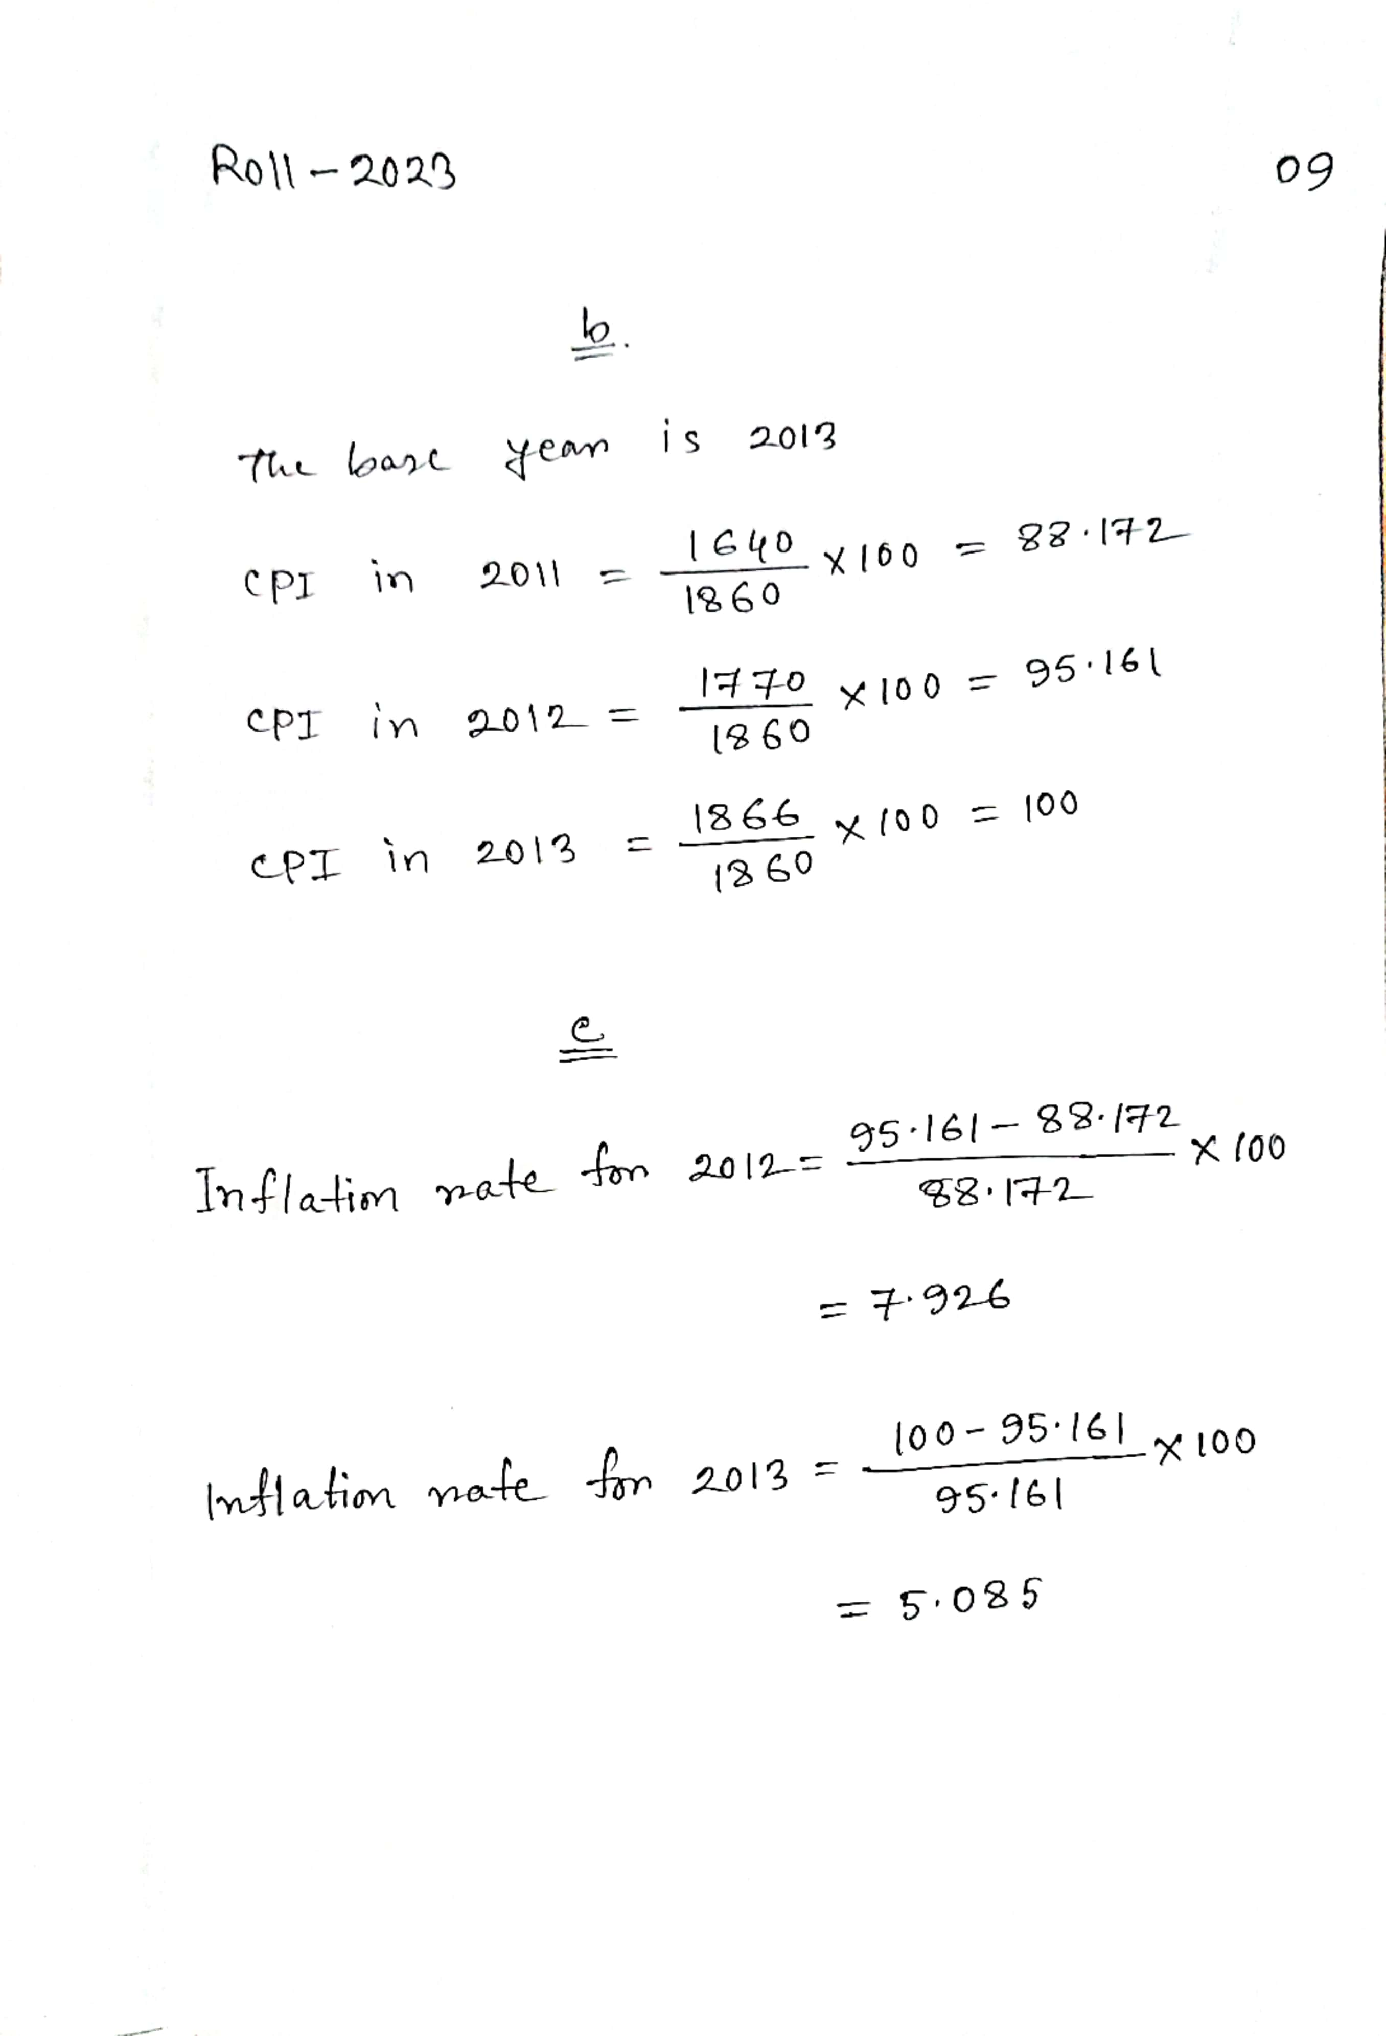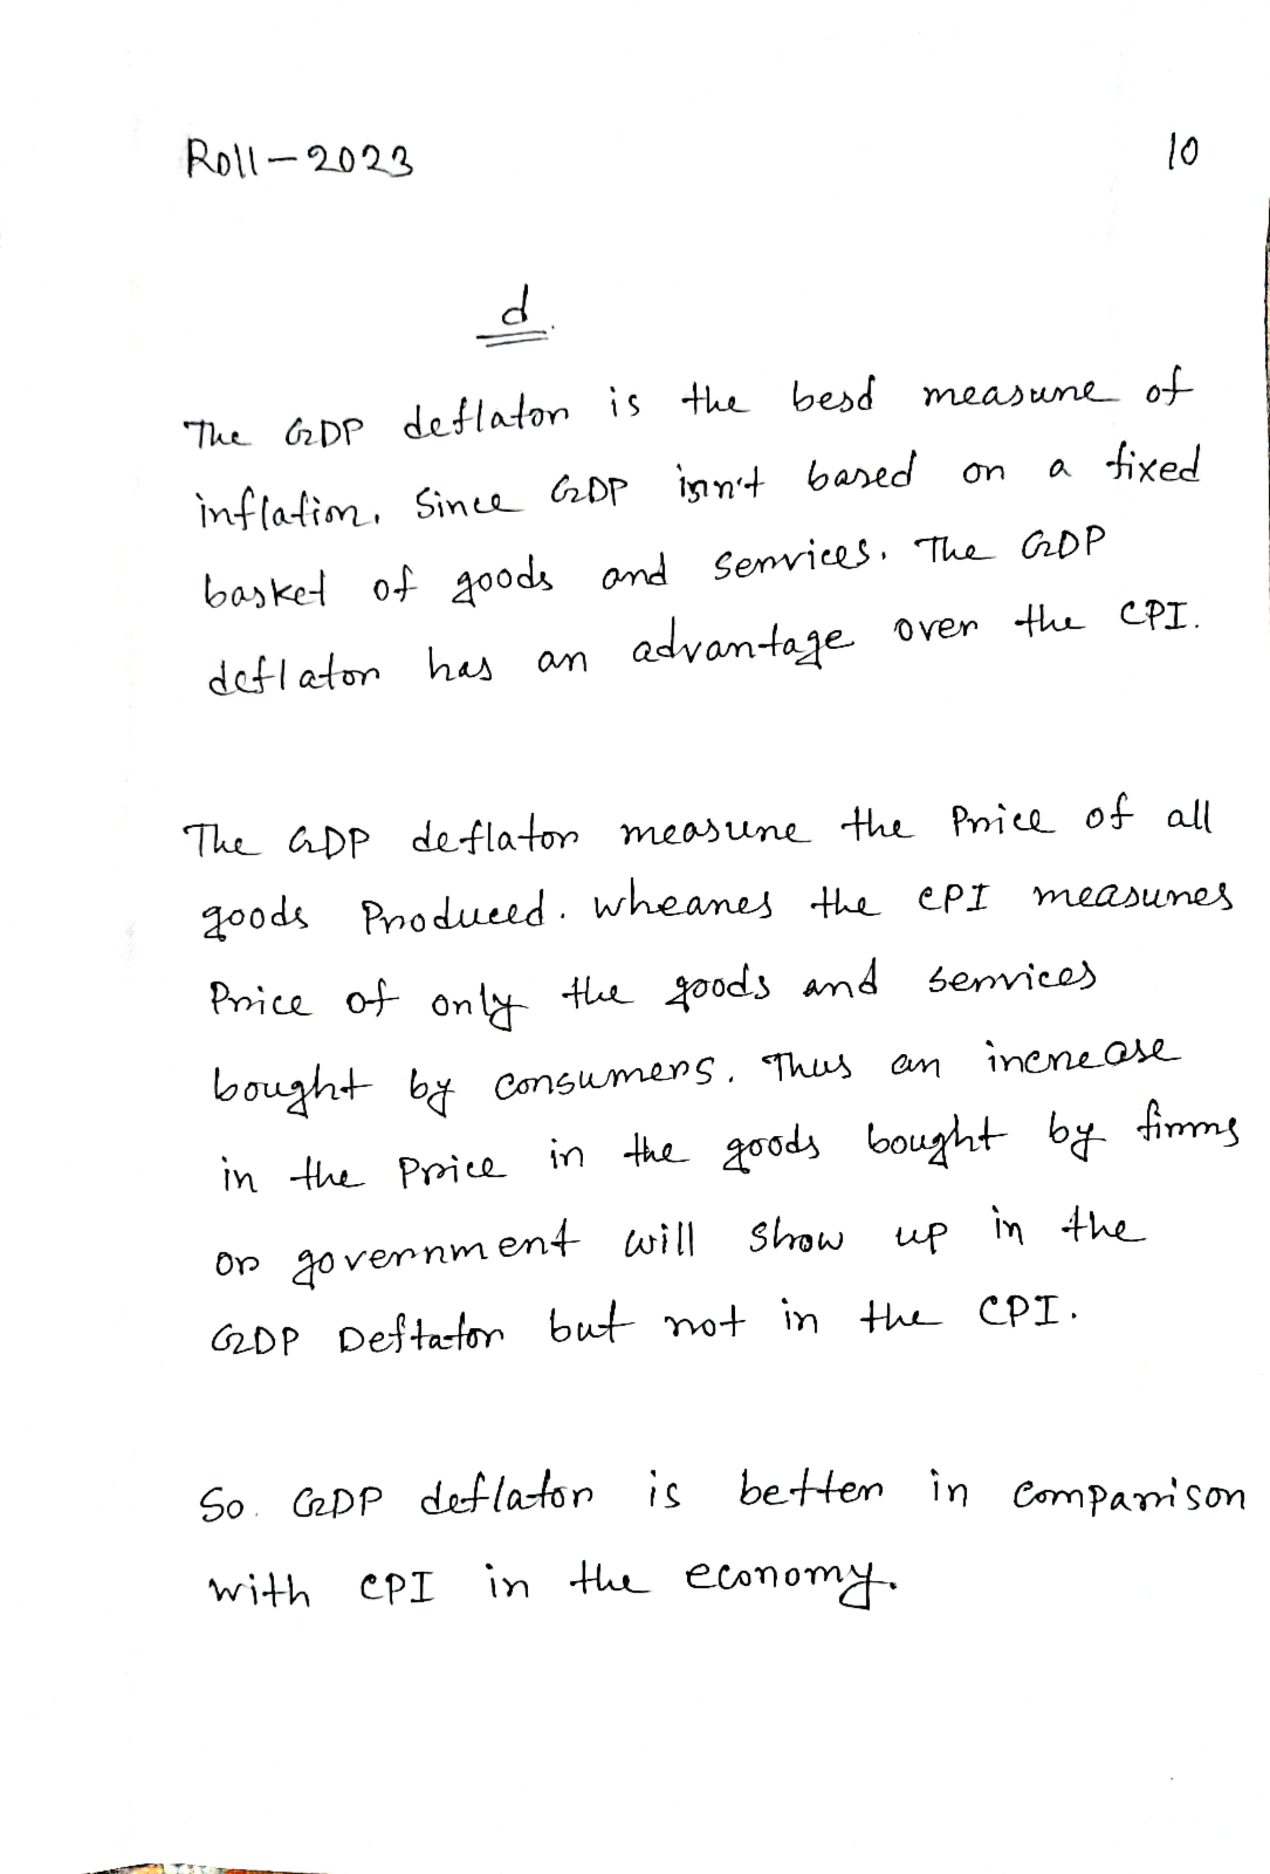

**THE END**